Adoption Agreement and Application

Description of Dog/Cat: Adopter Information:

Pet Name: Breed/Color:

Financial Responsibility:
Name(s): Address: City: State: Zip:
Email:
Phone Number:

I understand that I will be responsible for ALL further financial needs including; booster vaccines, deworming, illness, injury,
and all other expenses that may occur during ownership. Any exceptions will be listed below and signed and approved by
Amy Roman. Exceptions:

Agreement:
- The animal will receive proper food and water, shelter, and a loving humane treatment, and will not be left alone for extended periods of time (more than an average work day).
- I understand that 100 Plus Abandoned Dogs of Everglades Florida (“100 Plus”), does not have extensive knowledge of the animal, including its medical condition/background and disposition. 100 Plus makes no warranties with regard to the health of the animal or animal’s behavior and disclaims any liability for the animal’s medical condition, sickness, disease or behaviors.
- When I assume ownership, the animal will receive annual vaccinations and monthly Heart Worm Protection according to a veterinary schedule, and will be treated immediately for any illness or injury that may occur.
- The animal will not be subject to harassment and will be protected from other animals in my care.
- I release 100 Plus, volunteers, crew, fosters, representatives, and the veterinary hospital treating the animal at the request of 100 Plus, from any and all claims and actions including but not limited to property damage, personal injury to me, family members, other individuals and other animals from biting, scratching, transmittal of disease, and/or any other matter attributable to said animal (s).
- Adoption Fee: Minimum donation of $225.00

I UNDERSTAND AND AGREE TO THE ABOVE TERMS. I UNDERSTAND THAT IF I KNOWINGLY FAIL TO COMPLY WITH THE ABOVE TERMS, OR IN ANY WAY PUT THE ANIMAL IN A SITUATION WHICH ENDANGERS ITS HEALTH, 100 PLUS MAY TAKE APPROPRIATE ACTION, INCLUDING RESUMING OWNERSHIP OF THE ANIMAL AND/OR LEGAL ACTION AGAINST ME.

Adopter signature Printed Name Date

100 Plus Abandoned Dogs of Everglades Florida
345 E. Commercial Blvd.
Oakland Park, FL 33334
100PlusAbandonedDogs@gmail.com
877.506.8100

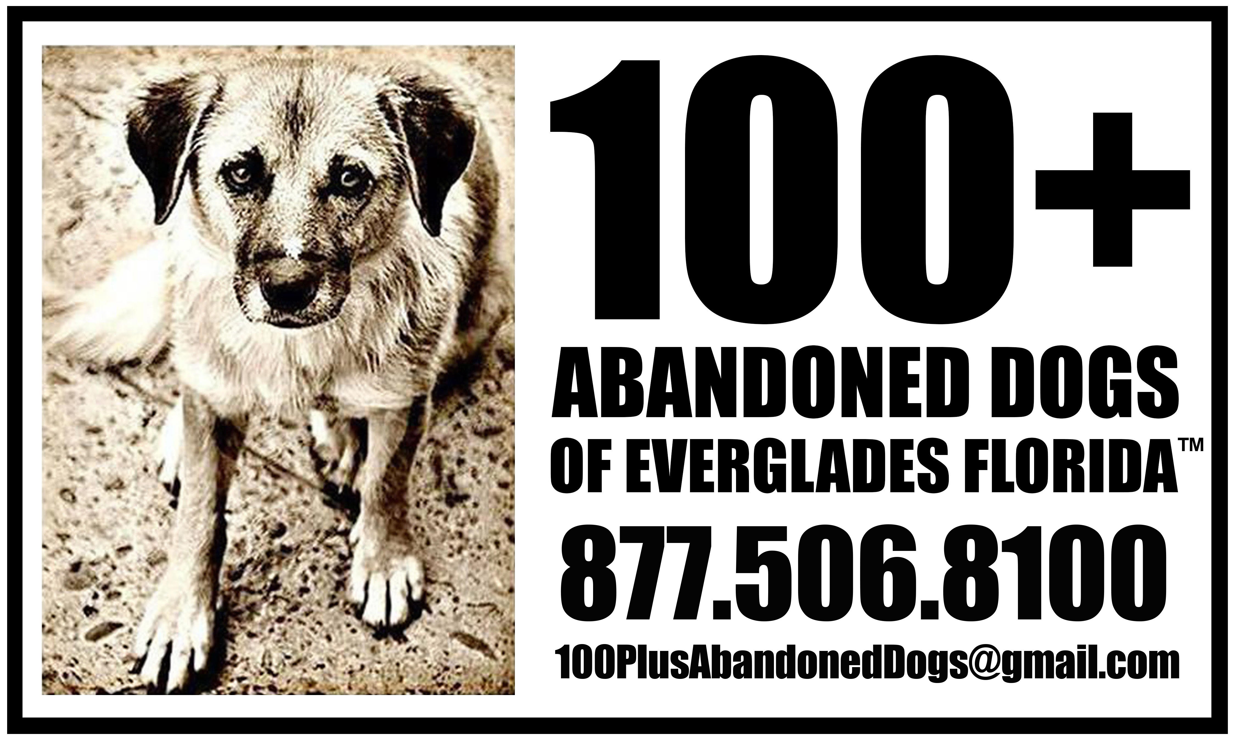

Animal Name: _________________________________Breed:_________________________________M/F: __________

Microchip Number:____________________________________________

***************************************************************************************************

Applicant Information:
Applicant Full Name: DOB: / / Cell: ( )
Home :( ) E-mail Address: _________________
Address: City: State: Zip:

Family/Household Information:
Number of adults in household/Ages: Number of children in household/Ages: Type of Residence: Own Rent_________

If Rent
Landlord Name: Phone ( )

Homeowner’s Association?______Y_____N
Any Pet Restrictions?_____N/A____Size______Weight____# of Pets____Breed Restrictions?________

Fenced in yard Yes No
Pool Yes No, If Yes, Enclosed? Yes No

Employment Information:
Work from home? Yes No
Employer: Work Phone: ( ) Working Hours:
Attend School: Yes No If Yes, Is anyone home during the day? Yes No How many hours per day will your pet be without human companionship?
Pet Information:
Do you have current pets? Yes No
If Yes, please fill out below. If No, have you had pets in the past?

Name: | Breed: | Age: | M/F | N/S | Current location?

Veterinarian Information:
Veterinarian’s Name:

Veterinarian’s Phone :( )

Address: Are your current pets up-to-date?
City State Zip

Vaccines? Y N HW prevention Y N Flea Prevention Y N
Have you ever given an animal away or relinquished an animal to a shelter? Y N
If yes, what were the circumstances?

******************************************************************************************* Where will your dog be housed during the day? Crated Inside loose Other
Where will your dog be kept when unsupervised or when left alone? Crated Inside loose Other Where will dog sleep? Crated Inside loose/bed Other
Who in the household will be the dog’s primary care giver? In case of emergency, who will care for your dog? How many times per day do you plan to take your dog outside?

PLEASE READ CAREFULLY
- Adopting a pet is a serious and long term commitment. A pet you adopt today will likely be a part of your family for the next 10 to 15 years! Each pet has its own personality and preferences that you can help shape through love and conscientious training.
- A dog makes considerable demands on your time and resources. Dog parents need to spend time walking, grooming, training, and playing with their dogs every day. Some dogs may require professional grooming or training.
- Dogs require special food and regular veterinary care. This includes annual vaccination and MONTHLY PREVENTIVE MEDICATIONS FOR HEARTWORM, FLEAS AND TICKS! Even in the case of healthy animals, these expenses can exceed
$1,500 a year.
- If you are adopting a PUPPY, please be aware that they may not be finished with the required puppy shots. It is the Adopter’s responsibility to ensure that your Puppy receives the required additional vaccinations.
- 100+ Abandoned Dogs of Everglades Florida has the right to request proof of required additional puppy vaccinations.
- I agree to care for the animal in a humane manner and be a responsible animal guardian. This includes supplying adequate food, water, shelter, attention, and medical care. (initial)
- Are you prepared to accept the financial and personal responsibility for a pet? Yes No
- A representative from 100+ Abandoned Dogs of Everglades Florida may follow up with you and your pet by visiting you in your home or by talking with you over the phone. We would visit your residence by appointment only. Are you willing to allow a 100+ Abandoned Dogs of Everglades Florida representative to periodically follow up to see how the dog is doing in his/her new home? Yes No
- I agree that if at any point I cannot keep the animal, I will return him/her to 100+ Abandoned Dogs of Everglades Florida. (initial)
- I understand that 100+ Abandoned Dogs of Everglades Florida has the right to deny any application.
- I give permission for a representative of 100+ Abandoned Dogs of Everglades Florida to call the references and veterinary practices I have listed.

This is a legally binding contract.
I agree that all statements I have made on this application are true. If it is found that any statements I have made on this application are not true, the adopted animal will be confiscated and brought back into the loving care of 100+ Abandoned Dogs of Everglades Florida.

All Household Residents must be in Total Agreement of the Adoption. All persons residing in the residence above the age of 18 must sign and date.

Applicant Signature |  | Applicant Printed Name |  | Date
Applicant Signature |  | Applicant Printed Name |  | Date
Applicant Signature |  | Applicant Printed Name |  | Date

This Application has been approved by 100+ Abandoned Dogs of Everglades Florida.

Crew Member Signature Crew Member Printed Name Date Initials Adoption Fee Rec’d.

